**Climate Adaptation in Colombia: designing an adaptive compensation and rewards program for ecosystem services**

By César Freddy Suarez, Nicole West, Luis German Naranjo, Ilvia Niño, Nirmal Bhagabati, Carmen Candelo, Amy Rosenthal, and Emily McKenzie

**Key Message**

The rain and cloud forests of Colombia’s Upper Putumayo region are threatened by advancing agriculture, ranching, and infrastructure development. These activities can have adverse effects on the benefits nature provides, including water supply and quality, soil erosion, carbon capture and sequestration, and biodiversity. The impacts of climate change intensify these effects, which is likely to have serious consequences for future development. To identify areas in the Upper Putumayo that supply multiple ecosystem services and could be at risk from climate change, InVEST was used to map regionally important services and compare their provision under different climate scenarios. Areas with the largest concentration of ecosystem services and greatest vulnerability to the effects of climate change are now being considered as priority sites for conservation actions. Two such actions are: 1) the establishment of silvopastoral systems, which incorporate strategically located tree cover on ranchlands, and 2) compensation and rewards for ecosystem services (CRES) schemes, which create incentives for better land management.

**What is the problem?**

The Sibundoy valley, in Colombia’s Upper Putumayo region, is endowed with a wealth of biodiversity and natural resources. The Putumayo River, a tributary to the Amazon River, flows through it. The valley and surrounding Andean foothills are covered in rain and cloud forests. The landscape provides essential ecosystem services for the local population, such as water supply, pollution regulation, and erosion control, as well as benefits for the globe through carbon sequestration and biodiversity (WWF Colombia & Corpoamazonía, 2010). Yet, this ecosystem service-rich area faces three interlinked problems: 1) agriculture and ranching operations and large-scale infrastructure projects are encroaching on natural ecosystems, which provide critical services for local populations; 2) the expansion of these projects cannot be avoided as they provide livelihoods to local people and contribute to Colombia’s economy; and 3) climate change is exacerbating the deleterious effects of these activities, by increasing the average temperature and variability of precipitation.

Excessive use of fertilizers and pesticides by farmers, and animal manure from ranching, can contaminate the Putumayo River, which is needed as a continuous source of clean water. Forests keep soil from eroding; clearing too much forest cover for farming and ranching can facilitate the loss of nutrient-rich soils. Poorly planned infrastructure development can affect availability of important wildlife habitat and non-timber forest products, such as medicinal plants and rubber, decrease water flow, and impede migration of fish, a major source of protein for local people. The construction of the Pasto-Mocoa Highway has the potential to cause many of these ecosystem service impacts, in particular reduction in water flow to the city of San Francisco (Consorcio DIN - SEDIC, 2008). In addition, construction and associated development could lead to widespread deforestation, emitting the carbon stored in rain and cloud forests and contributing to climate change.

In order to foster sustainable economic development in the region and minimize potential losses from climate change, there is a need to develop a system that better balances the short- and long-term interests of Colombians by maintaining and enhancing the ecosystem services they depend on.

**What is done to solve this problem and what is the role of local policy?**

The World Wildlife Fund (WWF) is working with its partners – Corpoamazonía, the regional environmental regulatory agency, and the Foundation Center for Sustainable Agricultural Systems, a nonprofit research organization – to identify areas in the Upper Putumayo basin with especially high ecosystem service value, for incorporation into a compensation and rewards for ecosystem services (CRES) scheme. A CRES scheme involves creating contracts for compensation or providing incentives for ecosystem stewards to protect and enhance ecosystem services, or reduce their degradation, for the benefit of users. CRES schemes differ from payments for ecosystem services (PES) schemes in that no market is set up to facilitate the payment transfers. Compensation can flow both ways – to the ecosystem stewards and to ecosystem service beneficiaries. Ecosystem service providers may pay compensation to beneficiaries to offset a decline in ecosystem services. Alternatively, ecosystem service beneficiaries may pay compensation to providers to reduce economic activities that degrade ecosystem services (Swallow et al., 2007).

WWF is investigating which areas would be suitable for silvopastoral systems, in which trees are strategically planted in pastures, along water bodies, and as living fences. This is done to increase the ecosystem services provided by the ranchland, such as reduced soil erosion and nutrient pollution. Trees supply shade for livestock, increase biodiversity by providing habitat, are a source of timber and non-timber forest products, and contribute to regulation of the water supply – all of which support local livelihoods (Svadlenak-Gomez, 2009). In addition, this practice can reduce pressure on surrounding rain and cloud forests as sources of timber and increase the resiliency of ecosystems vulnerable to climate change.

With local decision-makers and Corpoamazonía, WWF has developed a stakeholder engagement process known as *conversatorios*, which aim to identify optimal tracts for silvopastoral systems and the establishment of a CRES scheme. The *conversatorios* can also be used by stakeholders as a vehicle to influence development policies and land management decisions, as well as a capacity-building tool for participation, negotiation, and collective action. Because it is costly for farmers and ranchers to engage in silvopastoral systems, a CRES scheme will help to offset the start-up costs and provide an incentive for participation. Farmers and ranchers will be paid based on the value of ecosystem service benefits arising from their silvopastoral activities. The ecosystem services that forests provide can be bundled together and valued to determine the appropriate level of compensation. Similar schemes have established successful models that can inform the *conversatorios*, such as the Regional Integrated Silvopastoral Ecosystem Management Project that was established in Colombia, Nicaragua, and Costa Rica with support from the World Bank and Food and Agriculture Organization (Svadlenak-Gomez, 2009).

**What has been achieved?**

WWF used a software tool developed by the Natural Capital Project called InVEST (Integrated Valuation of Ecosystem Services and Tradeoffs) to assess the ecosystem services in the Upper Putumayo region. In its analysis, WWF used the carbon storage and sequestration, sediment retention, water purification (nutrient retention), biodiversity, and water supply modules (Tallis et al., 2011). The results showed that the areas around the municipalities of Sibundoy and Santiago had the greatest carbon sequestration capacity; the San Pedro, San Francisco, and Putumayo sub-catchments had the highest water yield; land near waterways offered the most nutrient retention; and San Pedro, San Francisco, and Hidráulica had the greatest erosion control. The most biodiverse areas were located at higher elevations, which were farther away from roads and infrastructure development (WWF Colombia & Corpoamazonía, 2010).

Locations with the highest concentrations of services, the greatest risk of loss from incompatible activities, or potential to increase services provide the greatest amount of benefits to ecosystem stewards and beneficiaries, making the sites good candidates for CRES schemes. WWF Colombia and Corpoamazonía have selected pilot locations for silvopastoral systems, using InVEST to identify where there is potential for enhancing ecosystem services in degraded areas and for conservation in areas with high concentration of services.

In order to take the increasing influence of climate change into account, WWF used a regional climate change model called PRECIS, developed by the Ecuadorian Ministry of the Environment and the Meteorological Institute of Cuba (MAE & INSMET, 2008), which projects changes in precipitation and temperature under two greenhouse gas emissions scenarios. Integrating the PRECIS projections with current land-use information, WWF created two future scenarios for the region and ran them through InVEST to estimate changes in water supply and erosion control. Results revealed that in the driest period (2040-2045) precipitation in the Upper Putumayo basin will likely decrease by 55% and flows in major rivers will decrease by 45%, endangering the region’s water supply. In the wettest years, (2055-2060) rainfall is predicted to increase by 100% and flows in major rivers will almost double, greatly increasing risk of flooding (WWF Colombia & Corpoamazonía, 2010).

WWF researchers found that the areas that will experience increases in annual precipitation could also see a doubling in the amount of soil erosion. As a result, the threat of siltation and sedimentation of waterways and irrigation systems will increase significantly, raising the risk of flooding. The economic implications of these changes include damage to irrigation systems and infrastructure projects, higher operation costs, crop failure and reduced harvests, and difficulty sustaining ranching operations.

The relationship between areas rich in water supply (Fig. 1) and soil erosion (Fig. 2) is depicted in the InVEST maps below. These maps demonstrate that areas with the highest levels of water yield today (in pink and purple in Fig. 1) are also the most susceptible to soil erosion in the future (areas in red and orange in Fig. 2), especially in the wettest years modeled, due to the effects of climate change on precipitation. These results indicate a looming threat to agricultural and ranching operations, infrastructure development, and local communities’ survival if ecosystem services are not protected or restored.

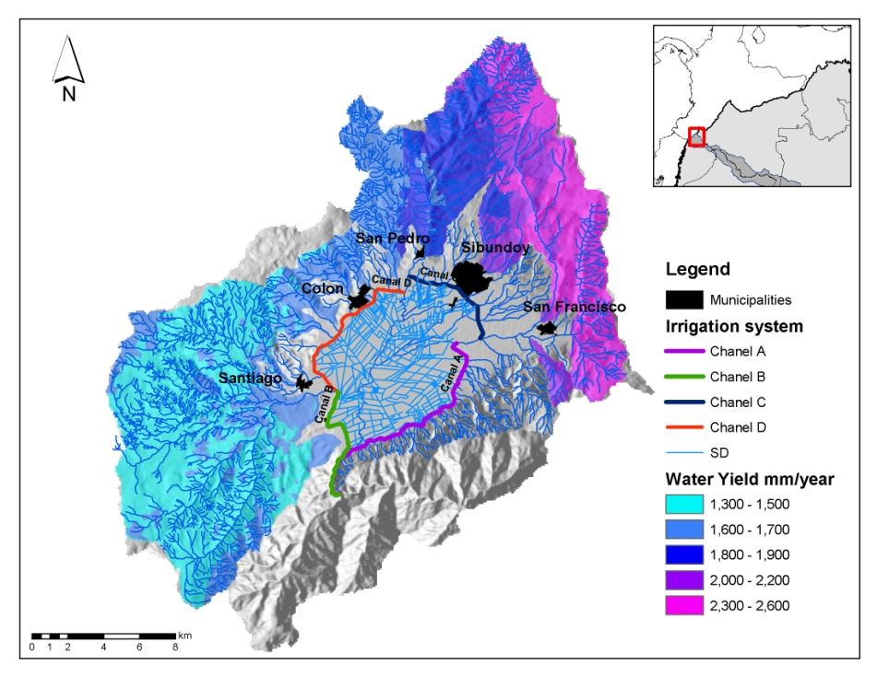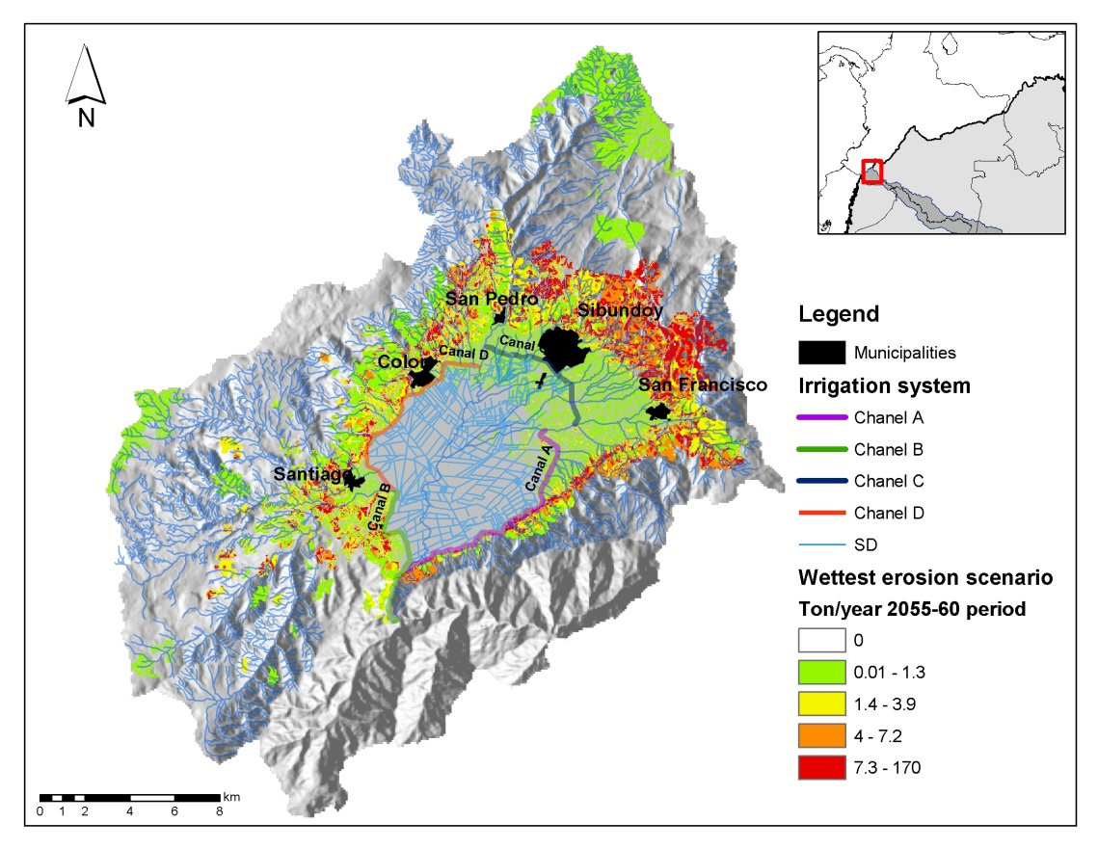

**Figure 1: Water yield and irrigation channels** **Figure 2: Potential impact of climate change on soil erosion**

WWF Colombia is sharing these findings with local stakeholders in the *conversatorios*, in order to foster dialogue about how silvopastoral systems and CRES schemes can be used to mitigate potential threats to livelihoods by enhancing critical ecosystem services, such as erosion control. Enhancing and restoring ecosystem service supply can also increase resiliency in ecosystems, which can help communities adapt to the effects of climate change. By educating and informing local stakeholders, WWF and its partners are building their capacity to use the *conversatorios* to influence policy and land management decisions in ways that better balance short- and long-term goals for Colombia.

**Sources:**

Consorcio DIN – SEDIC. (2008). Actualización y Complementación. Estudio de Impacto Ambiental Variante San Francisco – Mocoa. INVIAS. *Estudio de Impacto Ambiental*, 108.

MAE and INSMET. (2008). *Climate Change Scenarios in Ecuador using the PRECIS Regional Modeling System*. Quito: Environmental Ministry of Ecuador and the Meteorological Institute of Cuba.

Svadlenak-Gomez, K. (2009). *Paying for Silvopastoral Systems in Matiguás, Nicaragua*. Washington, DC: Ecoagriculture Partners. Retrieved from <http://www.ecoagriculture.org/case_study.php?id=73>.

Swallow, B., Kallesoe, M., Iftikhar, U., van Noordwijk, M., Bracer, C., Scherr, S., Raju, K.V., Poats, S., Duraiappah, A., Ochieng, B., Mallee, H., and Rumley, R. (2007). *Compensation and Rewards for Environmental Services in the Developing World: Framing Pan-Tropical Analysis and Comparison.* ICRAF Working Paper no. 32. Nairobi: World Agroforestry Centre. Retrieved from <http://www.rightsandresources.org/publication_details.php?publicationID=653>.

Tallis, H.T., Ricketts, T., Guerry, A.D., Nelson, E, Ennaanay, D., Wolny, S, Olwero, N., Vigerstol, K., Pennington, D., Mendoza, G.,.Aukema, J., Foster, J., Forrest, J., Cameron, D, Lonsdorf, E., Kennedy, C., Verutes, G., Kim, C.K., Guannel, G., Papenfus, M., Toft, J., Marsik, M., Bernhardt, J., Wood, S., and Sharp, R. (2011). *InVEST 2.1 Beta User’s Guide*. The Natural Capital Project, Stanford.

WWF Colombia and Corpoamazonía. (2010). Desarrollo y validación del esquema de compensación por servicios ambientales y reconversión de sistemas ganaderos en cuencas hidrográficas abastecedoras de acueductos municipales pertenecientes a la cuenca del río Putumayo. Unpublished report.